# Game Document for Ruin of Radiance

# Level Design

Our current plans for how levels will be laid out and organized.

## Link to our Spreadsheet

Enemies and tiles per level.

<https://docs.google.com/spreadsheets/d/1zrDY2bgbJw0_4Yyp4Hb_2A_8GVztwHd0JGMZNiugB7M/edit#gid=1667666483>

## Tutorial level: (Sewers or in one building)

(this level plus level 1 are the length of the other levels)

Introduce Movement

Introduce your basic attack: Melee ability like a stab. 1 action, low damage

Introduce toggling to your basic ranged ability: a Light ray. 1 action, low damage

Introduce summoning creatures: actions to summon a Rat

-A tutorial fight

-A real fight where you can choose whatever you want.

## Level 1: Uptown City

(this level plus tutorial are the length of the other levels)

-2-3 fights increasing difficulty

-The raccoon mob boss fight.

Gain “raccoons” as an infinite item that sticks with you for the rest of the game.

Then move onto the main city location or level 2

## Level 2: Downtown City

A multipart level where you move throughout the city

-A few fights

-A miniboss fight

-Some capturing fights

-Boss fight against the rat king

Then move onto the Crystal Meteor location or level 3.

## Level 3: Crystal Meteor

A multipart level where you move throughout the mose irradiated part of the city. (Probably an Island or something)

-A few fights

-A miniboss fight

-Some capturing fights

-Boss fight against the Crystal Golem

Then you absorb the golem’s crystals and become the overlord of the ruined city!

# Gameplay and Mechanics

How does the game actually work at a conceptual level?

## In world travel

Top down Stardew style, explore and walk around to find encounters. Look around corners and interact with objects to fight enemies, obtain collectibles, and gain experience to improve your player!

## Combat -

When you encounter another creature that represents a group of creatures or a mandatory fight, you are taken to a different screen. Combat takes place on a side view screen with a 3x7 grid on it and you and enemies are placed on the grid.

### Creatures on the Field

Creatures on the grid share a number of consistent attributes:

HP Bar: a bar above the sprite’s head that indicates how close to death it is. When this drops to 0, the enemy becomes dead (A marker of some kind drops where it was? Or there is just a list at the end of battle of all creatures you can control from the battle?).

Action Dots: each creature has a number of actions. These are represented by dots underneath the HP bar. When a creature uses an action the dots go away. At the start of your turn or when a creature is summoned, the dots refresh.

Creature Sprite: what the creature looks like. Fully Animated sprites that have attack animations, movement animations, idle animations. When they die there is some other non animated sprite to represent their fallen form.

### The Player

Your Statistics

HP: your life force. Is only set to full when you reach a checkpoint. (Gardener raccoons have gardens you checkpoint at)

Crystal Energy (mind juice?, etc): what you use to exert your mind control powers. Is set to full at the start of any combat

Player Character Moves: You have 3 action points which can be used to do the following things.

Melee: Stab: 1 action 1 target. Medium damage

Ranged: Light beam: 1 action 1 target. Low damage

Movement: 1 action. Move 1 square 1 square

Special Moves

-Slash: 3 actions do medium damage in a 3 squares arc

There may be more special attacks as a stretch goal?

-Use creature: 2 action summon one or more creatures from your inventory. Some creatures may cost more or less. Summoning also costs Crystal Energy and the amount varies based on the creature summoned.

-Use creature raccoon. 3 actions, summon. Costs No energy. Raccoons are always at your disposal, but are annoying to use as it takes your whole turn to summon them.

-Consumables. Action number varies. You use something you have picked up.

Healing potions, Mana Potions, Crystal stuff? Tin can? etc.

Once you have chosen your moves and the moves of all the creatures you are currently controlling there is a Confirm button to lock in turns. Then all the creatures do their actions and play moves to the computer to move the enemies against you.

It costs Crystal Energy to summon creatures but also cost energy to return any that are not raccoons to your inventory. You can choose from any fallen creatures on the battlefield, even if you just defeated them.

### Upgrade Tree/XP

Radiance crystals work as xp and you gain them from each creature you defeat? Alternatively some other version of leveling up, your there are just abilities you gain after certain checkpoints?

3 branches of an upgrade tree

* Self-Plant Upgrades:
* Mind Controlled Creatures:
* Tools:
* Consumable Upgrades?: More health per fertilizers?

### Inventory system: - (unlimited storage)

Start with nothing and then in the tutorial be given a rat as your first companion.

Possum and raccoon as the next ones.

Further places offer more animals or monsters.

Obtainable object groupings

* Racoons - Unlimited slot
* Creatures (Rat, Pigeon, Feral Racoons, falcons, Boars)
* Consumable items (food, ‘powerups’)
* Special Items

Shops - Merchant Racoon

* Items for sale
  + Health and Energy consumables
  + Special Items
  + Creatures in cages?
  + Special Raccoons (stretch goal)

### Collectibles

* Pots that let you choose new pot texture/color
  + Color ___
* Racoon hats
  + Fedoras, Party, Sombrero, Top hat, Wire Trash can, Watermelon

### Tools

Lockpicks, Search, Heavy, Gardener Raccoon (Fills health)

### Sounds

Copyright free music, create sound effects, custom music (stretch)

Second page of this:

<https://docs.google.com/spreadsheets/d/1zrDY2bgbJw0_4Yyp4Hb_2A_8GVztwHd0JGMZNiugB7M/edit#gid=0>

Ambience

### NPC types + Characters (subject to change) +Enemies

Animated sprites: Self, Racoons,

Rat as first collectable in intro level.

Easy Enemies

* Rats (.5 animation) low hp, low damage
* Pigeons low hp, mid damage
* Basic Racoon
* Mob Raccoon (First Boss) high damage
  + Tommy gun, Tranquilizer

Mainline Enemies

* Feral Raccoons - mid hp,damage
* Falcon- mid hp,high damage,
  + Charge up attack, Meteor attack
* Boar - high hp, lower damage
  + Lane charging attack
  + Quick Close attack
* Rat King (middle boss) - High hp, spawns rats
  + Two Tiles Size
  + Spawn rat
  + Throw rats?
  + Smash attack

Crystal -

* Final Boss Enemy - Crystal Golem/Husk
  + Able to spawn smaller crystal enemies
  + 3 attacks tbd
* Crystal pigeon
* Crystal Rat
* Crystal Boar
* Crystal Falcon

Intro and boss fight work.

2 areas with boss fight in intro

5 or 6 enemies.

Schedule for artists. Scale back if not hitting.

Enemy strength

Rats

Pigeon

Raccoons

Falcons

Boars

Bosses

# Art and Assets

What do we need to create? Lists and stylistic choices.

Art Style

* Stardew style pixel. 16 by 16 tiles likely, (After some testing may decide that 32 by 32 is better)
* Top-down orthographic for the overworld map.
* In Combat Screen, side view, partial 3D flat characters on a 7x3 grid overlaid upon each other to create the illusion of depth.

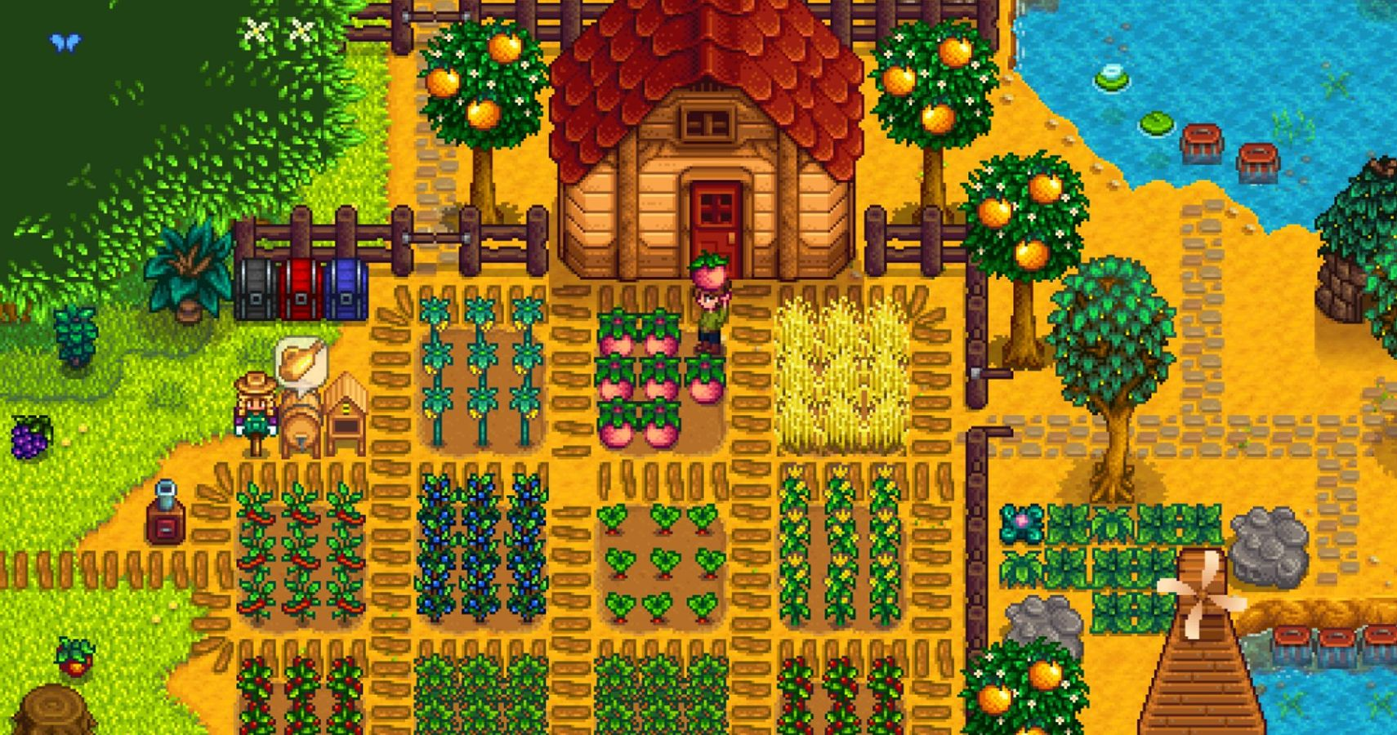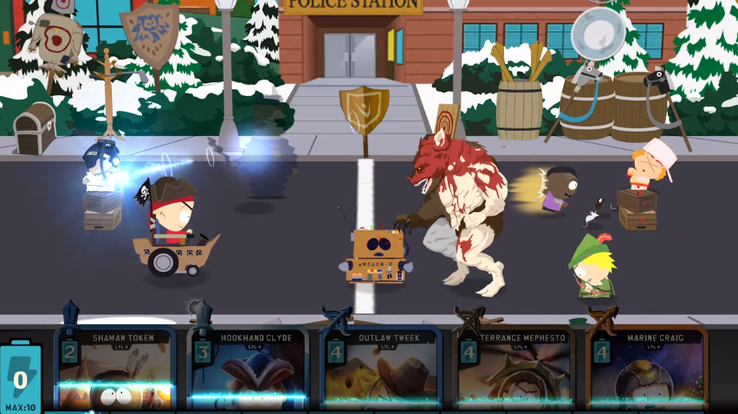

Early character concept art

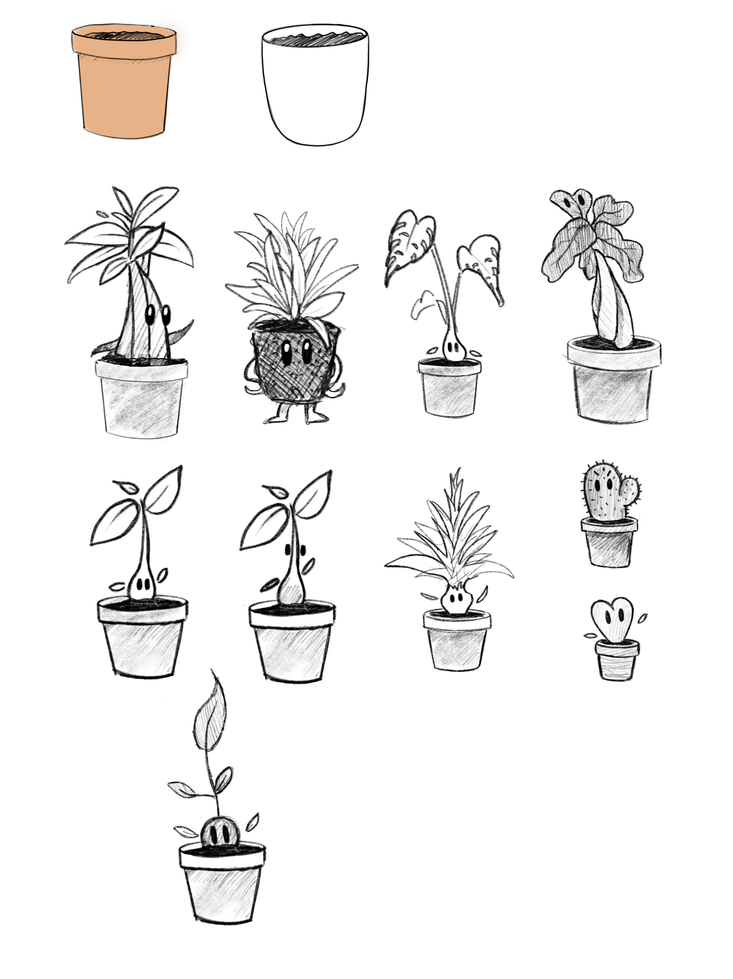

## UI

Inventory Screen/Menu sketch + reference idea

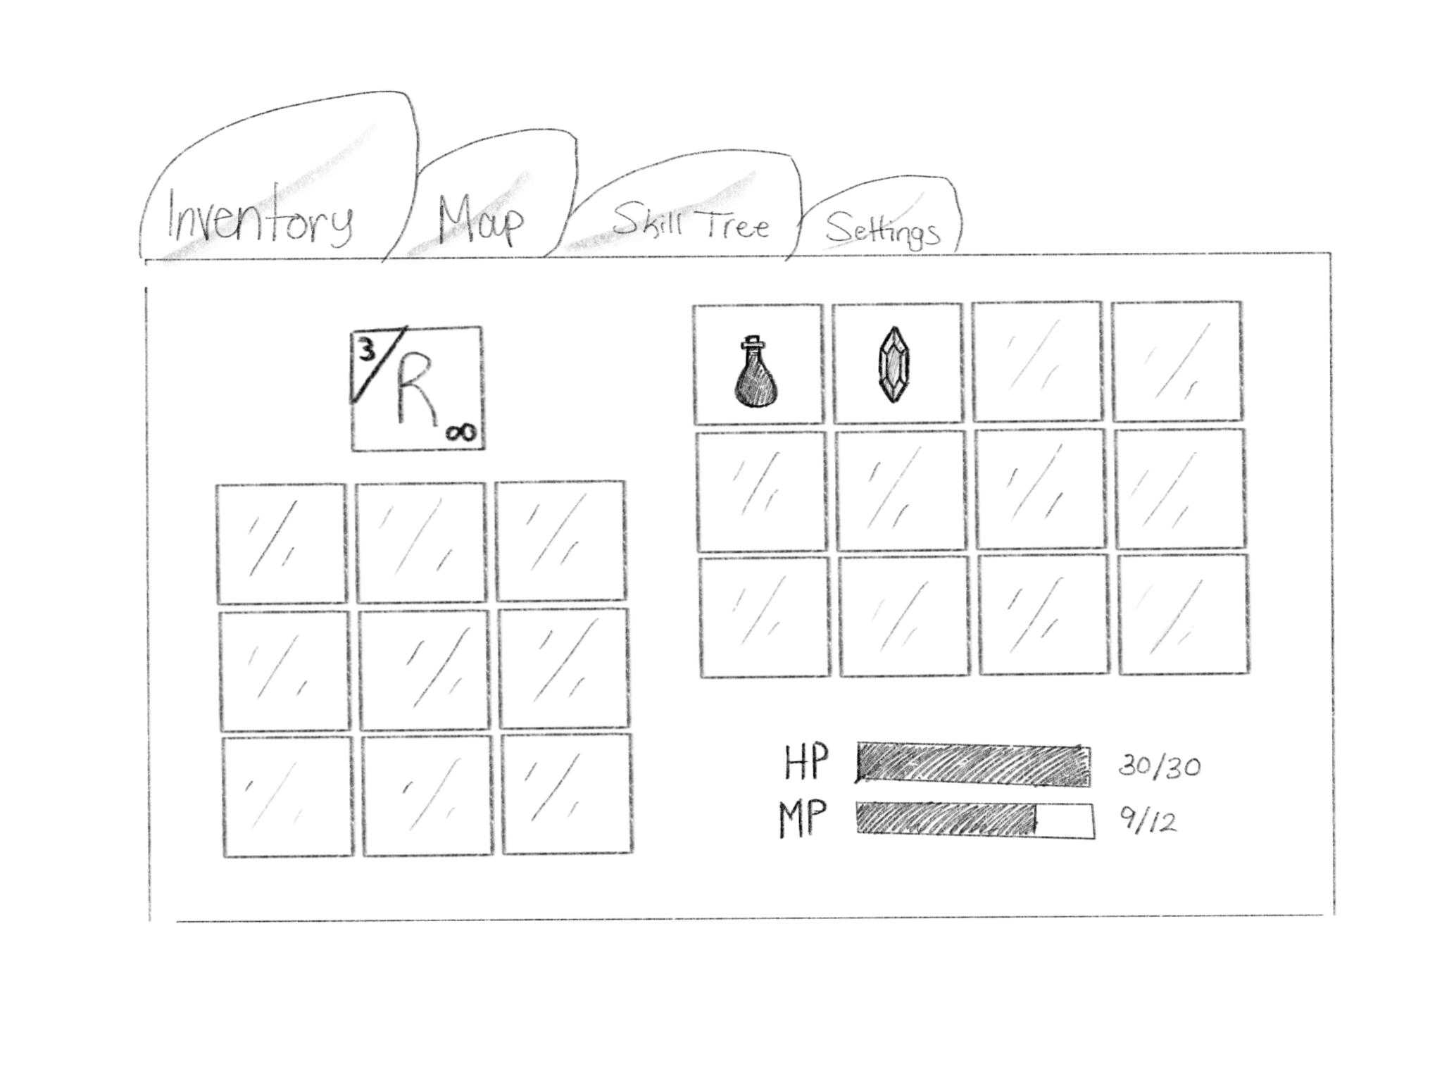

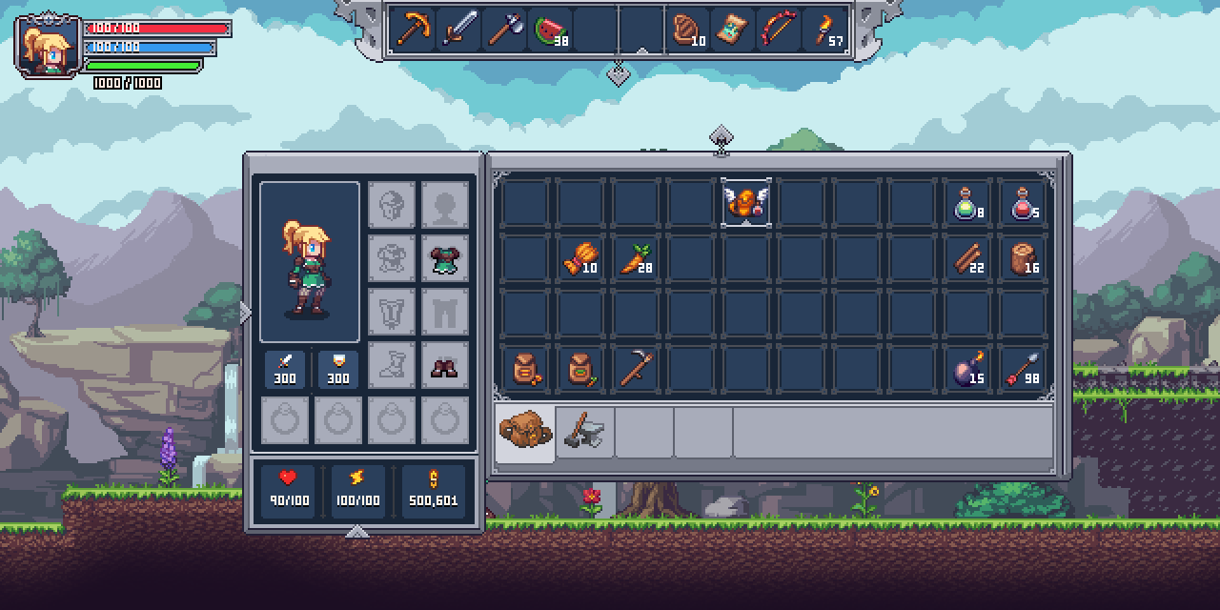

Skill Tree reference

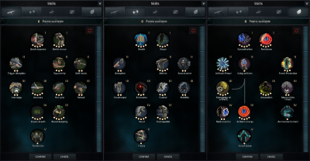

Combat view UI sketch

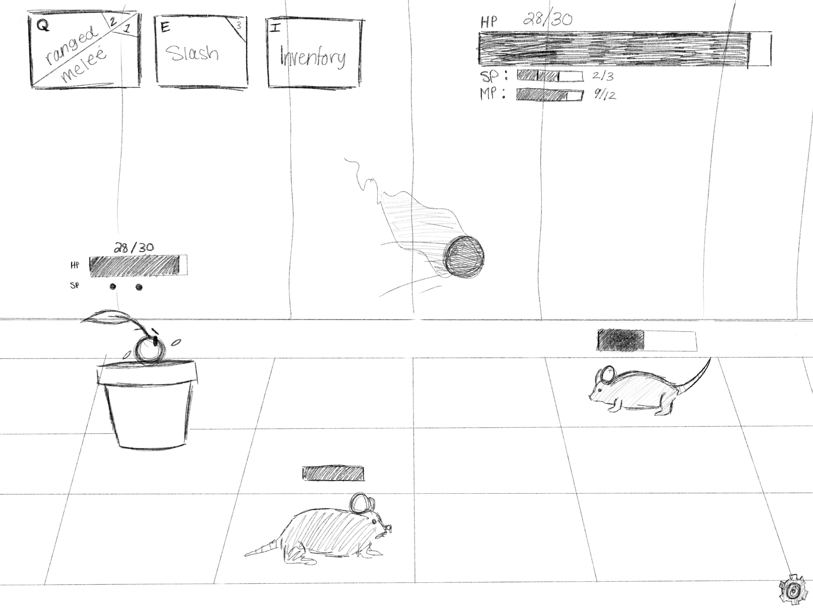

# Story and Maps

What is the overarching story, and this is where the overworld map will be put. Level maps too maybe??

(Original Pitch)

Marketing description: You were once a peaceful houseplant but the stars the humans brought down upon the earth have scorched the land and leveled their cities, uprooting you from your home. With nothing to keep you in your pot, you now roam the broken streets with a goal of glory and prestige. You play as a sentient plant infused with radiance crystals in this new post-human world who is out to conquer a portion of the ruined city using your newfound mind control abilities.

Hook: In this RPG you conquer your own section of a post-apocalyptic city making alliances with other non-human creatures or defeating them with a good ol' stick to the face. You are infused with what are basically irradiated crystals and the more you have the more creatures you can control.

High concept: What if you were an irradiated plant with the ability to mind control critters and the ambition to take over a city. This game will allow you to do that through RPG dialogue and battles in which you pit your party of allies against foes.

· Develop a cult following of racoons or other creatures and train them to fight on your behalf.

· Explore the empty shells of buildings and convert the creatures you find into friends or destroy them.

· Fight through the domains of other infused creatures and collect their radiance crystals, allowing you to control more creatures.

· Strategy battles using many creatures under your thrall

· Be a power-hungry plant with magical powers

Origins/Backstory of character

* Plant given sentience by radiation crystal
* Wakes up in sewer
* Is able to absorb crystals in order to gain power
* Grows as they are given more power

## Maps

The look of how the overworld will be laid out.

A tutorial.

3 main “levels” you can walk around in. Finding items, and random enemies to farm and get stronger off of.

Each level will have 3 required combats to unlock the boss of that level.

Once you defeat the boss, you open the way to the next level.

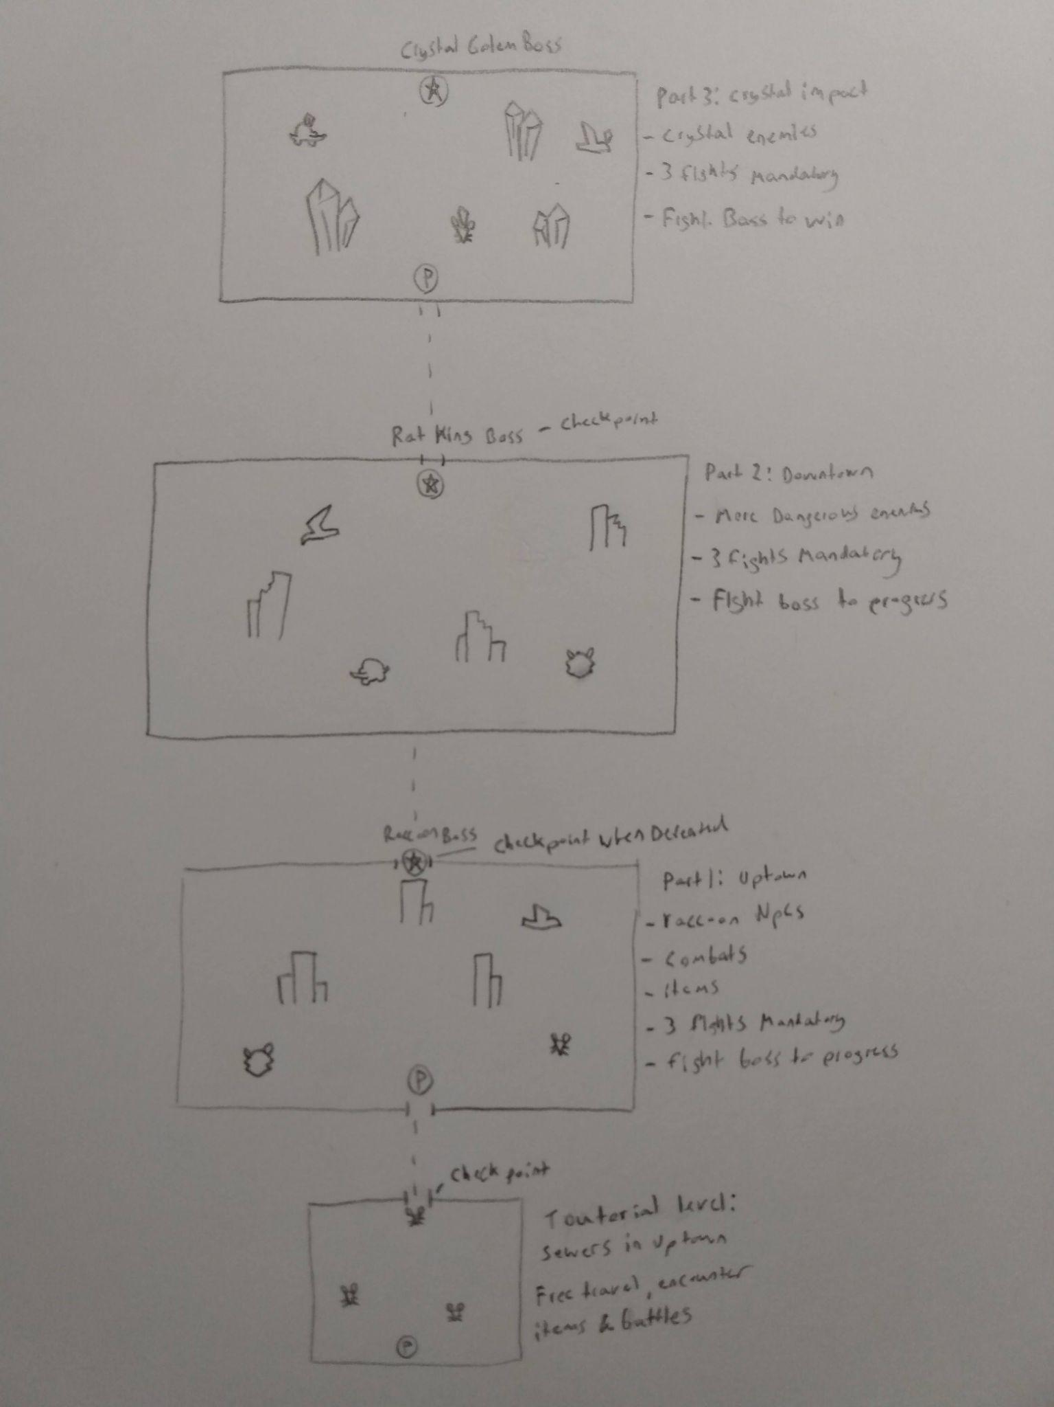

## Fights / Level Layout

Easy, moderate hard boss, format for each of the 3 areas.

Uptown -

* Boss - Raccoon Mob Boss

Downtown -

* Boss - Rat King

Crystal Zone -

* Final Boss - Crystal Golem

# Stretch Goals

* More combat encounters and item encounters
* Add more areas beyond main 3 (intro, mid, final)(BIG STRETCH)
* More enemy types
* More Customized Pots
* Player visual growth stages.
* Extra Forms of Racoons for combat
* Variations on enemies.
* Custom Music for each area
* Awful Puns as much as possible